THE ACCURACY OF QIBLA DIRECTION OF CEMETERIES USING MODERN QIBLA TOOLS

Suriah Pebriyani Jasmin

Fakultas Syariah dan Hukum Islam, IAIN Bone, Indonesia

Email: suriah.febri@iain-bone.ac.id

Ashar Anas

Fakultas Syariah dan Hukum Islam, IAIN Bone, Indonesia

Email: asharanas909@gmail.com,

Muspita Sari

Fakultas Syariah dan Hukum Islam, IAIN Bone, Indonesia

Email: muspita.sari@iain-bone.ac.id

Muh. Fadli Mangenre

Fakultas Tarbiyah, IAIN Bone, Indonesia

Email: fadlimuhammad680@gmail.com,

LD. Dian Hidayat S.

Fakultas Tarbiyah, IAIN Bone, Indonesia

Email: dian.hidayat@iain-bone.ac.id

Abstract
This article discusses the Qibla direction of cemeteries, especially in Bone District, by taking direct measurement at the location of the cemetery. This research is a field research which is oriented to several cemeteries in Bone District using qualitative descriptive analysis and multi-approaches, namely normative theological, sociological, historical, and modern technological approaches. The data collected through this research were obtained from direct observation at several public cemeteries in Bone District and documentation during the observation. The results show that the direction of the cemeteries at the research sites is different, so it can be concluded that the measurement of the Qibla direction at these locations still uses the classical method, such as following the direction where the sun sets in the evening and looking for clues through the stars at night to determine the Qibla direction, although those methods are still just an estimate due to the lack of public understanding of measuring the Qibla direction. From this research, the researchers hope that people will understand more about the Qibla direction, not only based on the place where the sun sets, but also determine the Qibla using astronomical tools, both manual and modern. In this way, the astronomical science will further develop and the issue of Qibla will no longer be a matter of debate, because it uses proper knowledge.

Keywords: Qibla Direction; Modern Qibla Tool; Cemetery;

Abstrak
Artikel ini bertujuan untuk mengetahui kondisi arah kiblat pekuburan khususnya di daerah Bone, dengan cara melakukan pengukuran langsung ke lokasi pekuburan. Jenis penelitian yang dilakukan ialah penelitian field research yang berorientasi pada beberapa lokasi pekuburan di Kab. Bone. dengan menggunakan analisis deskriptif kualitatif dan multi pendekatan, yaitu pendekatan teologis normatif, sosiologis, historis, dan pendekatan tekhnologi modern. Data yang dihasilkan dari penelitian ini diperoleh dari obervasi langsung ke beberapa pekuburan umum di Kabupaten Bone dan dokumentasi saat obervasi berlangsung. Hasil dari penelitian ini bahwa arah pekuburan yang ada di lokasi penelitian berbeda-beda, sehingga menyimpukan bahwa pengukuran arah kiblat di daerah tersebut menggunakan cara yang masih klasik seperti mengikuti arah matahari terbenam di sore hari dan melihat petunjuk melalui bintang di malam hari untuk menentukan arah kiblat yang mana cara tersebut masih sekedar perkiraan dikarenakan kurangnya pemahaman masyarakat tentang pengukuran arah kiblat. Dari penelitian ini, peneliti berharap bahwa masyarakat lebih memahami terkait dengan arah kiblat dan menentukan kiblat dengan menggunakan alat-alat falak, baik sifatnya manual maupun modern. Dengan demikian ilmu falak semakin berkembang dan persoalan kiblat tidak lagi menjadi hal yang diperdebatkan, sebab menggunakan ilmu yang tepat.

Kata Kunci: Arah Kiblat; Alat Kiblat Modern; Pekuburan;

Introduction
The word “Qibla” comes from Arabic. Qibla is a direction that refers to a place where the building of the Kaaba in Masjid al-Haram, Mecca, Saudi Arabia. The Kaaba is also often called Baitullah. The phrase "Qibla direction" is made up of two words: "direction," which means "line, destination, and intention." Another meaning is the closest distance measured through a large circle on the surface of the earth. There are also other meanings, namely jihad, syathrah, and azimuth.
According to Islamic law, facing the Qibla means that the entire body or a person's body is facing the Kaaba, which is the foundation of Muslims in carrying out certain worship. The direction of the Kaaba can be determined from any point or place on the earth's surface by doing calculations and measurements. Therefore, the calculation of Qibla direction is a calculation to determine which way the Kaaba in Mecca is seen from a certain place on the surface of the earth. The rules for determining the Qibla direction require special expertise that is justified so that it is in accordance with Islamic law.
There are two kinds of Qibla direction determination: first, looking for the Qibla direction, which must be exactly facing the Kaaba ('ain al-ka'bah), so that it must take a northwest direction. Second, just by looking for the direction (jihatul kaaba), it doesn't have to be exact like the first method; the exact direction to the west is sufficient, and if someone prays facing the exact west direction, his prayer is still valid. The existence of such a reality causes confusion among Indonesian Muslims, so there is a need for directions and explanations that can ease the people's anxiety.

Burying the corpse is one of the last steps in caring for the corpse. In the study of jurisprudence, there are several matters and rules regarding how to bury the body, which are arranged based on the sunnah and teachings implemented in Islamic teachings. One of the guidelines for burying the body is to face the Qibla direction. The way to face it should be to lay the body in the grave in a right-sided position, that is, the right limb is below and the face is facing towards the Qibla, while the head and both feet are towards the right and left of the Qibla. This is what Muslims have been doing since the time of the Prophet Muhammad (pbuh) until today. This is what Ibn Hazm said in the book al-Muhalla and other books.
The polemics on the Qibla direction continue to occur in society and are also triggered by the revision of the Fahwa from the Indonesian Ulema Council (MUI) number 03 of 2010 concerning Qibla, which among the dictums states that Indonesia's geographical location is east of the Kaaba/Mecca, so the Qibla of Muslims in Indonesia is facing west. This dictum is corrected in that, geographically, the territory of Indonesia is not exactly east of the Kaaba but slightly tilted to the south. So, the Qibla in Indonesian territory does not point to the west exactly but rather to the northwest.
Thus, the dissent from the scholars caused confusion among the people, and not a few even underestimated the Qibla direction. This, of course, means that the Qibla direction for each mosque or cemetery may differ from one another. Therefore, with the development of science, especially astronomy, the Qibla direction can be easily known. In addition, it is also a means of knowledge for the wider community that currently there is special knowledge that discusses Qibla direction, so that in the future there will be no more differences in understanding of Qibla direction in society.
In determining the Qibla direction of the cemetery, there is a lack of care or attention. At this time, it is mostly referring to the old cemetery or simply facing west. This is because people think that the Qibla direction of Indonesia is located to the west. Of course, this is incorrect because Indonesia is located in the eastern part of the Kaaba, or Mecca.
In this research, the researchers tried to make an accurate determination of the Qibla direction of cemeteries in Bone District, including: Islamic Cemetery of Bukaka, Islamic Cemetery of Macanang, Lahemma Cemetery of Apala, Islamic Cemetery of Majang, Islamic Cemetery on Jl. Pramuka, and A. Malla Islamic Cemetery, which are known to be public cemeteries specifically for Muslims. According to the researchers' observations, there are several Qibla directions for the graves in the cemeteries. So that, by conducting this research, which is aimed at improving the accuracy of the Qibla direction, subsequent burials can be carried out in accordance with the actual Qibla direction.

Method
This research is field research, and it was conducted to find out how the community determines the Qibla direction of cemeteries and the accuracy of the Qibla direction in cemeteries. Furthermore, researchers strive to examine as much data as possible about the object under study.

In this case, research sites are locations that are used as research areas and contain primary data sources. This research was conducted in Bone District, specifically at the Islamic Cemetery of Bukaka, Islamic Cemetery of Macanang, Lahemma Cemetery of Apala, Islamic Cemetery of Majang, Islamic Cemetery on Jl. Pramuka, and A. Malla Islamic Cemetery.
This research used normative theological, sociological, historical, and modern technological approaches in collecting data. As for the data collection technique, it involves direct observation by taking measurements directly at the research sites, conducting interviews with administrators and local residents regarding the Qibla direction of cemeteries, and conducting documentation during observations and interviews.
Data analysis techniques in this research involved data reduction, where the researcher summarized, understood the main points, focused on important things, looked for themes and patterns, and removed unnecessary data; data display, where in qualitative research, presentation of data is usually done in the form of descriptions in the form of narrative text; and drawing conclusions and verification, where conclusions in qualitative research are new findings that have never existed before. Findings can be in the form of a description of an object that was previously unclear and that, after research, becomes clear; they can be a causal or interactive relationship, hypothesis, or theory. The deductive data analysis technique is a data analysis technique that takes general facts, which are then analyzed to apply to specific matters.

Results and Discussion
The word "direction" in Arabic is called jihah or syathrah and is sometimes also called Qiblah, which comes from the word qabbala yaqbalu, which means facing. Qibla, which comes from Arabic (قبلة) is the direction that refers to a place, namely the Kaaba building in Masjid al-Haram, Mecca, Saudi Arabia. In Latin, however, it is known as azimuth. Thus, from a linguistic point of view, the Qibla means facing the Kaaba when praying and performing other acts of worship. Meanwhile, the direction itself is the closest distance from a place to Mecca.
The word “Qibla” comes from the Arabic القبلة, whose origin is مقبلة, the synonym of وجهة, which comes from the word مواجهة, which means the state of the direction faced. This means that Muslims who are in the east of the Kaaba face west, those in the west of the Kaaba face east, those in the north of the Kaaba face south, and those in the south of the Kaaba face north. Facing the Qibla is a form of masdar, which means facing the direction or the viewpoint for the validity of Muslim prayers or other acts of worship.
Facing the Qibla direction is an important issue in Islamic law. According to Islamic law, facing the Qibla is defined as the whole body or a person's body facing towards the Kaaba, a building located in Mecca, which is the center of support for Muslims to complete certain acts of worship.
The Qibla position is located in the Masjid al-Haram in the city of Makkah Al-Mukarramah. For people who live around the Grand Mosque, there is no problem regarding the Qibla direction because, in reality, they know the position of the Kaaba. That means for places that are far away, like South Sulawesi, it requires measurements to be able to pass right towards the Qibla.
Therefore, both the person who is praying and the corpse must face straight on the surface of the earth, which points to the center of the earth. As a projection, facing all limbs towards the Qibla. The person who is praying must stand in a place determined by the center point of the place and the Qibla direction. This measurement concerns the Qibla direction, so the results cannot be generalized to all cemeteries in the Bone District area. Each cemetery in the area must be measured separately.
Astronomically, Bone District is located at 4° 13'–5° 6' south latitude and between 119° 42'–120° 30' east longitude. Its location close to the equator gives Bone District a tropical climate, while the latitude and longitude of the Kaaba are 21° 25' 21.05" north latitude and 39° 49' 34.27" east longitude.
1. Geographical Data of Research Sites
- Islamic Cemetery of Macanang
The Islamic Cemetery of Macanang is located on Jl. MT. Haryono, Macanang Village, West Tanete Riattang Sub-District, Bone District. Astronomically, it is located at 4° 32' 21" south latitude and 120° 18' 17" east longitude.

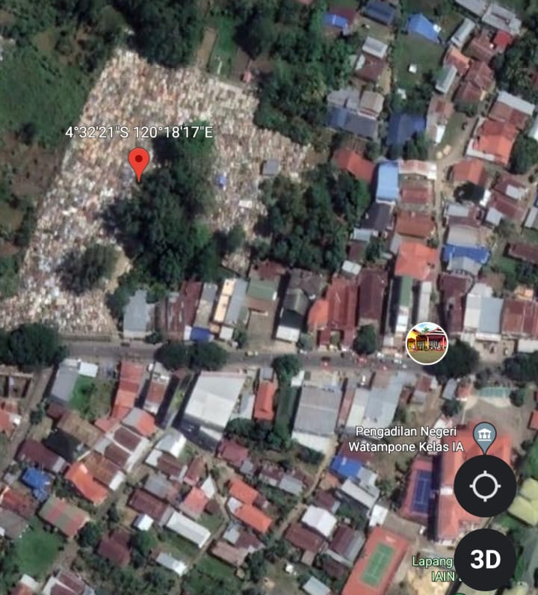
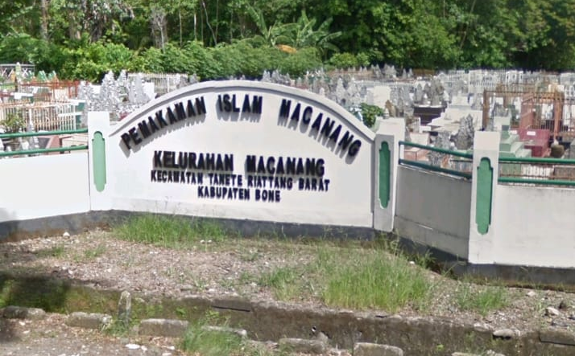

- Islamic Cemetery of Majang
The Islamic Cemetery of Majang is located on Jl. Majang, Macege Village, West Tanete Riattang Sub-District, Bone District. Astronomically, it is located at 4° 33' 03" south latitude and 120° 18' 33" east longitude.
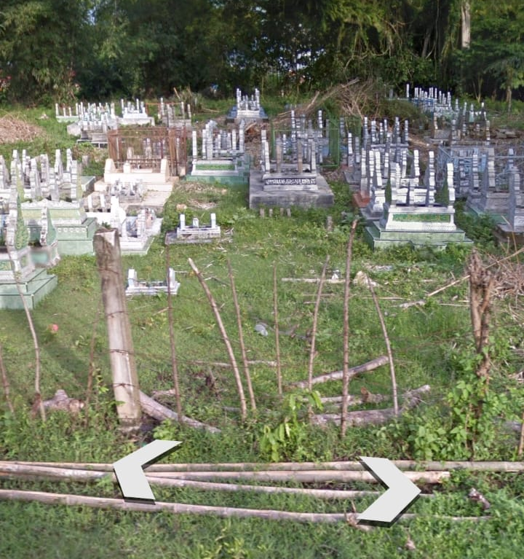

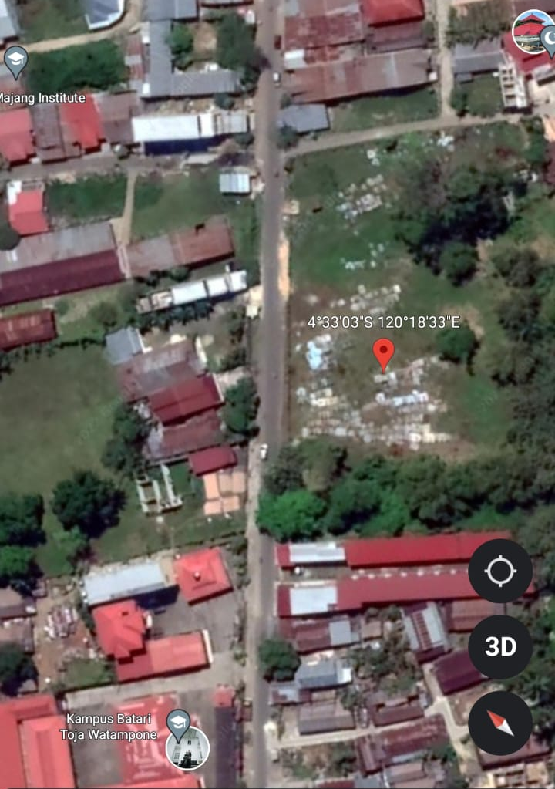

- Kalokkoe Islamic Cemetery of Bukaka
Kalokkoe Islamic Cemetery of Bukaka is located on Jl. Cempalagi, in Bukaka Village, Tanete Riattang Sub-District, Bone District. Astronomically, it is located at 4° 31' 56" south latitude and 120° 19' 51" east longitude.
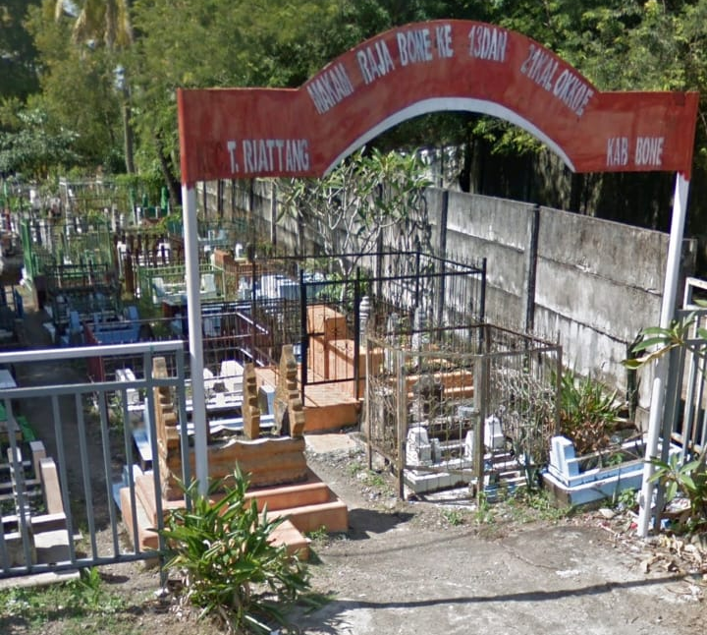

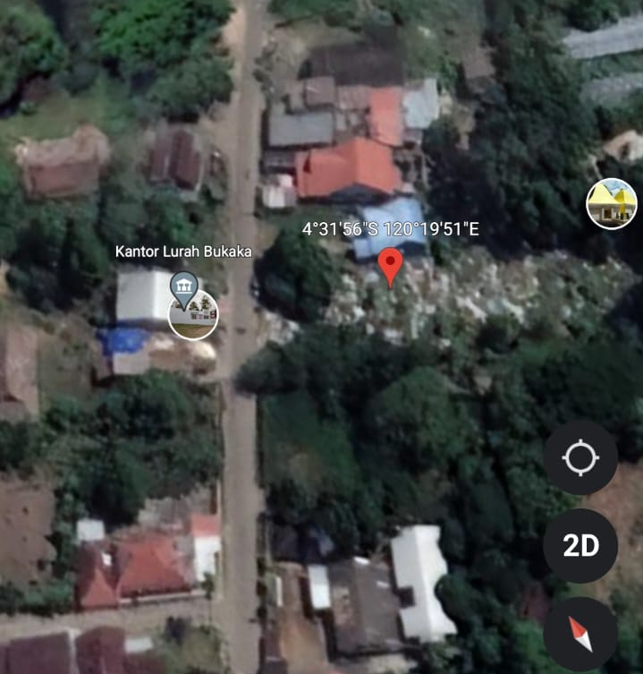

- A. Malla Islamic Cemetery
A. Malla Islamic Cemetery is located on Jl. A. Malla, Biru Village, Tanete Riattang Sub-District, Bone District. Astronomically, it is located at 4° 34' 14" south latitude and 120° 20' 05" east longitude.

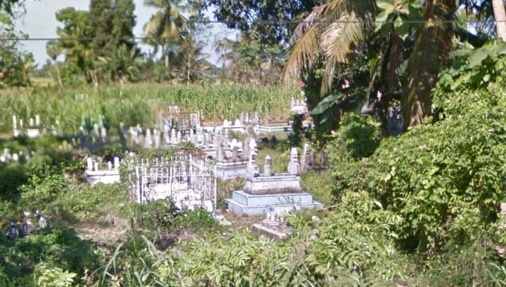

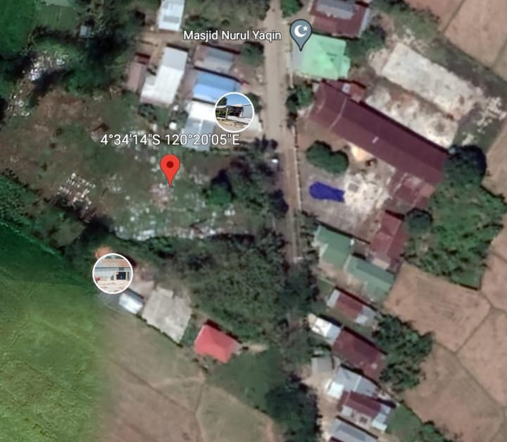

- Islamic Cemetery of Masumpu
The Islamic Cemetery of Masumpu is on Jl. Abu Dg Pasolong, Masumpu Village, Tanete Riattang Sub-District, Bone District. Astronomically, it is located at 4° 33' 08" south latitude and 120° 19' 59" east longitude.
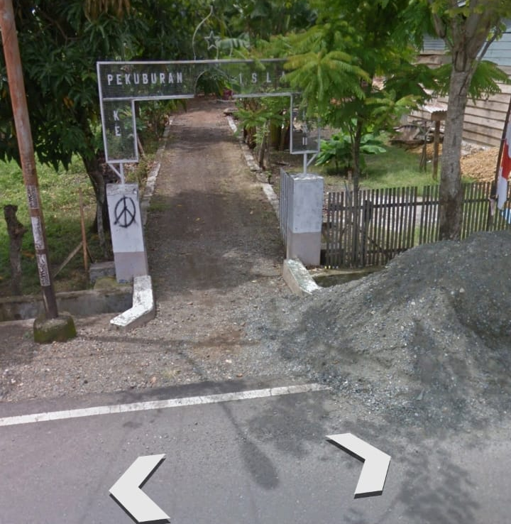

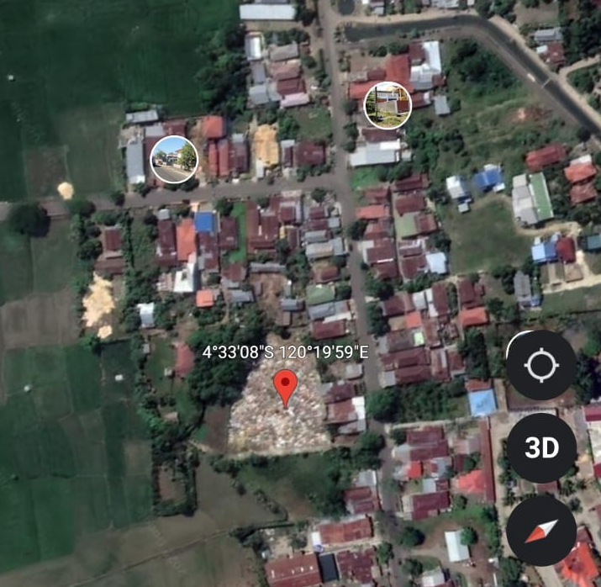

- Lahemma Islamic Cemetery of Apala
This Islamic cemetery is located in Apala Village, Barebbo Sub-District, Bone District. Astronomically, it is located at 4° 37' 00" south latitude and 120° 18' 47" east longitude.
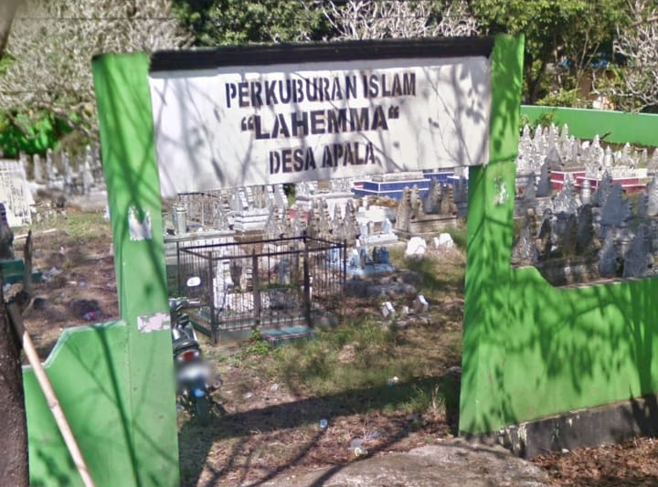

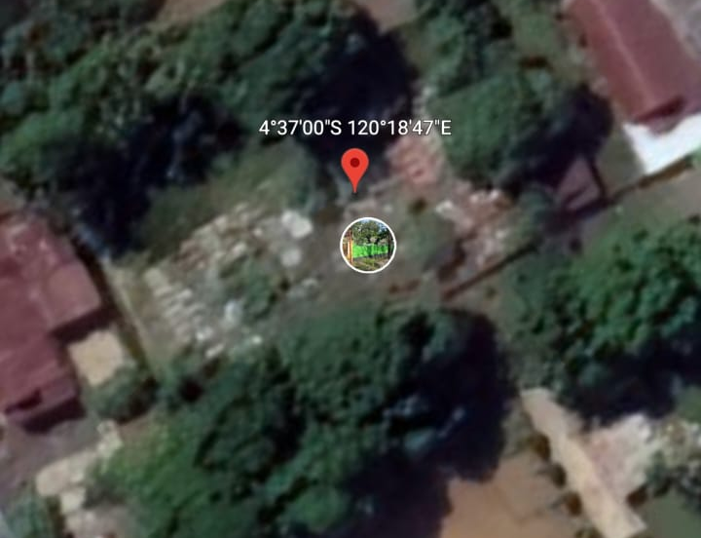

2. The Results of Qibla Direction Measurement/Accuracy
- Islamic Cemetery of Macanang
The Islamic Cemetery of Macanang is located on Jl. MT. Haryono, Macanang Village, West Tanete Riattang Sub-District, Bone District. The results of the Qibla direction calculation show that the Qibla direction of the city of Watampone is 292° from north-west/west to north. The accuracy results carried out using several modern tools, such as the Qibla tracker, sun compass, Qibla compass, mizwala, and istiwa aini, as well as the Dioptra application, show that most of the graves are deviated from the true Qibla direction. The deviation is approximately 12° which is obtained by calculating the Qibla deviation, in which the Qibla direction minus the direction of the grave building (292°-280°=12°), as evidenced by the following measurement results:
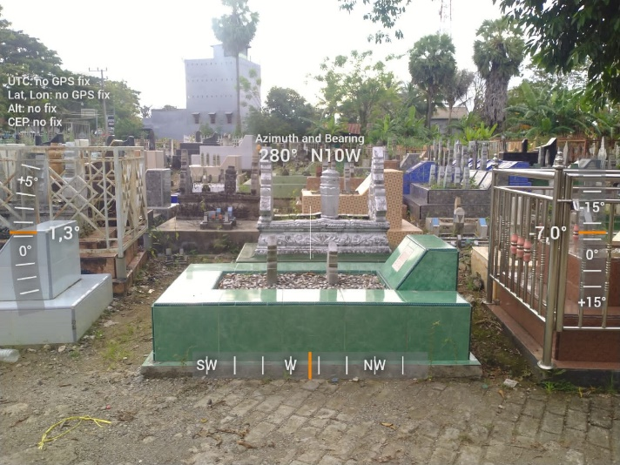

- Islamic Cemetery of Majang
The Islamic Cemetery of Macanang is located on Jl. Majang, in Macege Village, West Tanete Riattang Sub-District, Bone District. Astronomically, it is located at 4° 33' 03" south latitude and 120° 18' 33" east longitude. The results of the Qibla direction calculation show that the Qibla direction of the city of Watampone is at 292° from north-west/west to north. The accuracy results carried out using several modern tools, such as the Qibla tracker, sun compass, Qibla compass, mizwala and istiwa aini as well as the Dioptra application, show that most of the graves are deviated from the true Qibla direction. The deviation of about 25° is obtained based on the calculation of the Qibla deviation, in which the Qibla direction minus the direction of the grave building (292°-317°= 25°), as evidenced by the following measurement results:

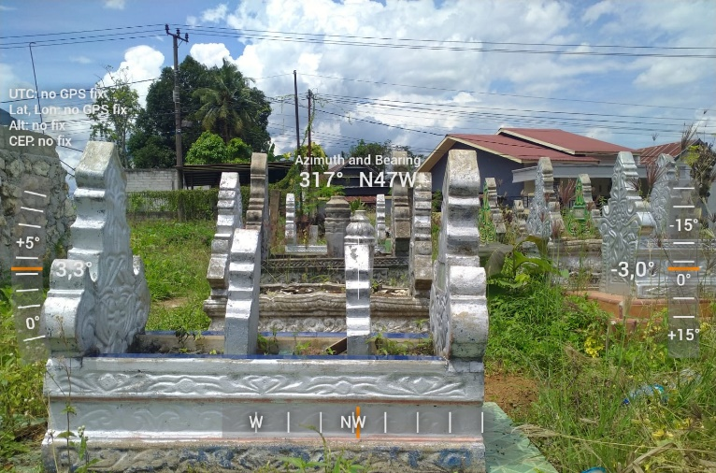

- Kalokkoe Islamic Cemetery of Bukaka
Kalokkoe Islamic Cemetery of Bukaka is located on Jl. Cempalagi, in Bukaka Village, Tanete Riattang Sub-District, Bone District. Astronomically, it is located at 4° 31' 56" south latitude and 120° 19' 51" east longitude. The results of the Qibla direction calculation show that the Qibla direction of the city of Watampone is 292° from north-west/west to north. The accuracy results carried out using several modern tools, such as the Qibla tracker, sun compass, Qibla compass, mizwala, and istiwa aini, as well as the Dioptra application, show that the direction of the graves is right towards the Qibla, as evidenced by the following measurement results:

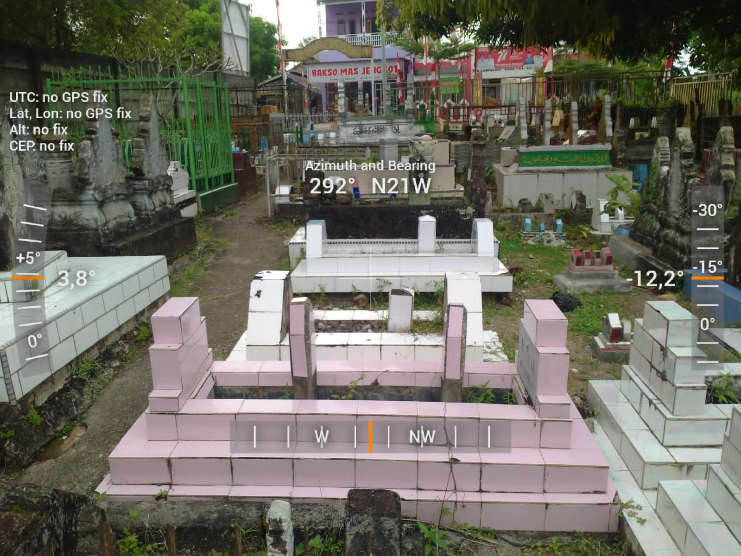

- A. Malla Islamic Cemetery
A. Malla Islamic Cemetery is located on Jl. A. Malla, Biru Village, Tanete Riattang Sub-District, Bone District. Astronomically, it is located at 4° 34' 14" south latitude and 120° 20' 05" east longitude. The results of the Qibla direction calculation show that the Qibla direction of the city of Watampone is 292° from north-west/west to north. The accuracy results carried out using several modern tools, such as the Qibla tracker, sun compass, Qibla compass, mizwala, and istiwa aini, as well as the Dioptra application, show that most of the graves are deviated from the true Qibla direction. The deviation of around 39° is obtained based on the calculation of the Qibla deviation, in which the Qibla direction minus the direction of the tomb building (292°-253°= 39°), as evidenced by the following measurement results:

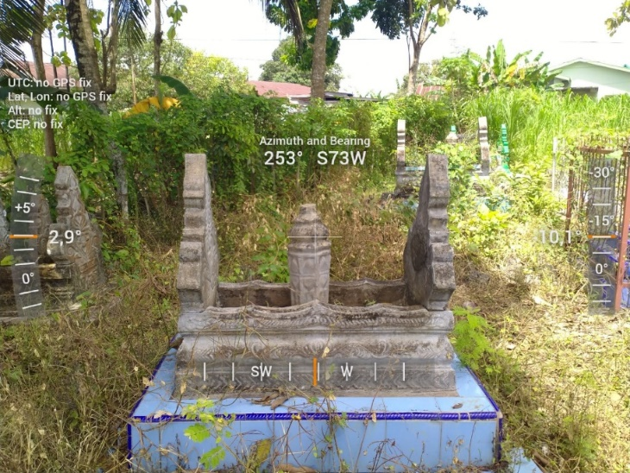

- Islamic Cemetery of Masumpu
The Islamic Cemetery of Masumpu is on Jl. Abu Dg Pasolong, Masumpu Village, Tanete Riattang Sub-District, Bone District. Astronomically, it is located at 4° 33' 08" south latitude and 120° 19' 59" east longitude. The results of the Qibla direction calculation show that the Qibla direction of the city of Watampone is 292° from north-west/west to north. The accuracy results carried out using several modern tools, such as the Qibla tracker, sun compass, Qibla compass, mizwala, and istiwa aini, as well as the Dioptra application, show that the direction of the graves differs from one another; some are exactly facing the Qibla and some are deviated far from the Qibla direction. The graves at this location can be said to be irregular because there is no clarity or uniformity of direction. So, it can be concluded that the direction of the cemetery in this location varies, as evidenced by the following measurement results:

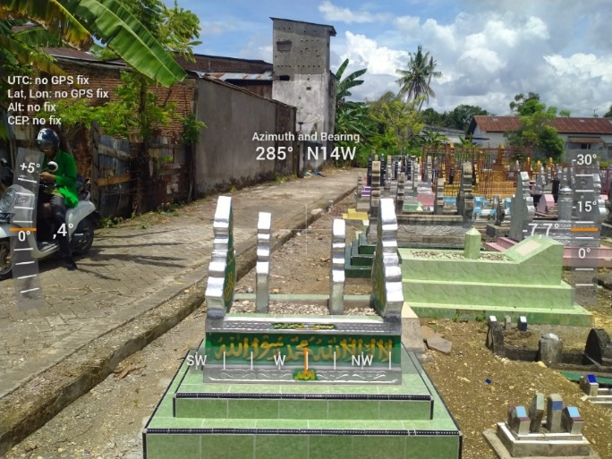

The grave that faces the Qibla

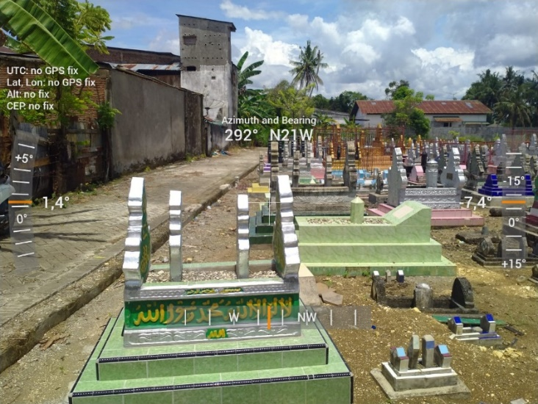

- Lahemma Islamic Cemetery of Apala
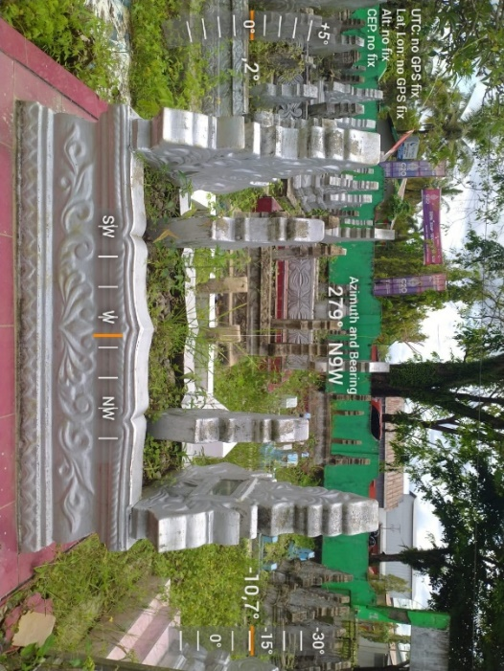
This Islamic cemetery is located in Apala Village, Barebbo Sub-District, Bone District. Astronomically, it is located at 4° 37' 00" south latitude and 120° 18' 47" east longitude. The results of the Qibla direction calculation show that the Qibla direction of the city of Watampone is 292° from north-west/west to north. The accuracy results carried out using several modern tools, such as the Qibla tracker, sun compass, Qibla compass, mizwala, and istiwa aini, as well as the Dioptra application, show that most of the graves are deviated from the true Qibla direction. The deviation of about 13° is obtained based on the calculation of the Qibla deviation, in which the Qibla direction minus the direction of the tomb building (292°-279°= 13°), as evidenced by the following measurement results:

Conclusion
Based on the description above, the researchers conclude that the Qibla problem, which focuses on the Qibla direction for cemeteries, especially in Bone District, is that there are still inaccuracies from the local community. This is evidenced by the position of the graves that were examined at the research sites, which did not show uniformity in the direction of the graves or from the six existing locations, only one of which pointed towards the Qibla. None of the graves in the cemetery deviate from the Qibla direction. Meanwhile, the other five locations still show differences from the several graves at each research site. This shows that the community still does not understand the Qibla direction and the importance of the Qibla direction for cemeteries. As a result, the purpose of this research is to educate the community about the direction of Qibla and the law of Qibla direction.

Bibliography
Izzan Ahmad and Iman Saifullah, “Studi Ilmu Falak Cara Mudah Belajar Ilmu Falak,” Banten: Pustaka Aulia Media, Cet Ke-1, 2013.

Ngamilah Ngamilah, “Polemik Arah Kiblat Dan Solusinya Dalam Perspektif Al-Qur’an,” Millati: Journal of Islamic Studies and Humanities 1, no. 1 (2016): 81–102.

M Nashiruddin Al-albani, Fiqih Lengkap Mengurus Jenazah (Gema Insani, 2020).

Agus Yusrun Nafi, “Verifikasi Fatwa MUI Nomor 03 Tahun 2010 Tentang Arah Kiblat,” Mahkamah: Jurnal Kajian Hukum Islam 9, no. 1 (2016).

Ahmad Warson Al-Munawwir, “Kamus Al-Munawwir Arab-Indonesia Terlengkap” (Yogyakarta: Pustaka Progressif, 1997).

Ahmad Izzuddin, “Metode Penentuan Arah Kiblat Dan Akurasinya,” 2012.

Jan van den Brink and Marja Meeder, “Kiblat Arah Tepat Menuju Mekah, Disadur Oleh Andi Hakim Nasution Dari ‘Mecca,’” Jakarta: Litera Antar Nusa, 1993.

Abdullah Ibrahim, Ilmu Falak: Antara Fiqih Dan Astronomi (Fajar Pustaka Baru, 2017).

Penentuan koordinat Ka’bah menggunakan aplikasi Google Earth Pro 7.3.2.5776 (64bit) versi online, diakses Kamis 27 Juni 2019 pukul 08.30 wita.

Izzan Ahmad and Iman Saifullah, “Studi Ilmu Falak Cara Mudah Belajar Ilmu Falak,” Banten: Pustaka Aulia Media, Cet Ke-1, 2013.
Ngamilah Ngamilah, “Polemik Arah Kiblat Dan Solusinya Dalam Perspektif Al-Qur’an,” Millati: Journal of Islamic Studies and Humanities 1, no. 1 (2016): 81–102.
M Nashiruddin Al-albani, Fiqih Lengkap Mengurus Jenazah (Gema Insani, 2020).
Agus Yusrun Nafi, “Verifikasi Fatwa MUI Nomor 03 Tahun 2010 Tentang Arah Kiblat,” Mahkamah: Jurnal Kajian Hukum Islam 9, no. 1 (2016).
Ahmad Warson Al-Munawwir, “Kamus Al-Munawwir Arab-Indonesia Terlengkap” (Yogyakarta: Pustaka Progressif, 1997).
Izzan Ahmad and Iman Saifullah, “Studi Ilmu Falak Cara Mudah Belajar Ilmu Falak,” Banten: Pustaka Aulia Media, Cet Ke-1, 2013.
Ahmad Izzuddin, “Metode Penentuan Arah Kiblat Dan Akurasinya,” 2012.
Jan van den Brink and Marja Meeder, “Kiblat Arah Tepat Menuju Mekah, Disadur Oleh Andi Hakim Nasution Dari ‘Mecca,’” Jakarta: Litera Antar Nusa, 1993.
Abdullah Ibrahim, Ilmu Falak: Antara Fiqih Dan Astronomi (Fajar Pustaka Baru, 2017).
Izzan Ahmad and Iman Saifullah, “Studi Ilmu Falak Cara Mudah Belajar Ilmu Falak,” Banten: Pustaka Aulia Media, Cet Ke-1, 2013.
Penentuan koordinat Ka’bah menggunakan aplikasi Google Earth Pro 7.3.2.5776 (64bit) versi online, diakses Kamis 27 Juni 2019 pukul 08.30 wita.

